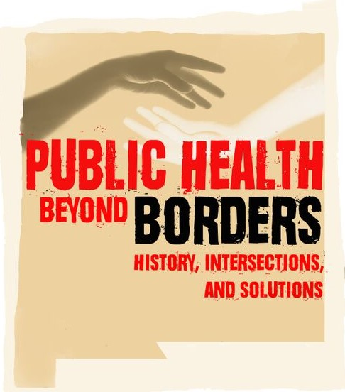
New Mexico Public Health Association (NMPHA)
2016 Annual Conference
April 11 - April 13th 2016
Las Cruces Convention Center ~ Las Cruces, NM

Public Health beyond Borders: History, Intersections, and Solutions

Information and Forms for Exhibitors

The New Mexico Public Health Association (NMPHA) invites you to participate in our annual conference at the Las Cruces Convention Center, Las Cruces, NM. We are seeking exhibits from government agencies, academic institutions, community groups, advocacy organizations, educational programs, and small businesses.

Exhibitors are invited to be participants and attend all conference events, including lunch and the awards ceremony. There will be time set aside for participants to see all the exhibits and it may not be necessary to staff the table at all times.

The fee includes lunch for one person on April 12th and April 13th, one table draped and skirted, 2 chairs and electricity. Power strips and/or extension cords will be an additional charge. You are welcome to bring your own. Organizations are welcome to share a table. Please contact us for more information about this.

Set up will begin at 7:00 a.m. on Tuesday April 12th and take down will be on Wednesday April 13th at 4:00 p.m. You can choose to participate on one day or both days. Please indicate your preference on the form provided.

To register your exhibit, please send this form to: nmphasubmissions@gmail.com. You can send a check in the mail or go to www.nmpha.org to pay online. Go to the “Donate to NMPHA” tab, and then click on the “Annual Conference Exhibitor Payment” button to pay your total exhibitor fees.
The total should include:

- Exhibitor fee total PLUS
- $25 for each additional person accompanying you (if any). This covers breakfast, lunch & snacks.

Once you have submitted payment, please remember to register each person sitting at your table by:

  - Contacting Melissa Candelaria, New Mexico Health Resources, 505-260-0993 to obtain your registration code, and
  - Entering the registration code at www.nmpha.org, “Table/Exhibitor” button under Registration

New Mexico Public Health Association (NMPHA)
2016 Annual Conference
April 11 - April 13th 2016
Las Cruces Convention Center ~ Las Cruces, NM

Public Health beyond Borders: History, Intersections, and Solutions

EXHIBITOR REPLY FORM

Name of Organization (as it should appear for conference publicity)

Contact Person Address City State

Phone Fax Email

Please indicate the days you plan to attend: April 12 April 13 Both days

Please check one:
Government agency (local, state, or federal) 1 day $95.00; both days $125.00

Academic Institution 1 day $95.00; both days $125.00

Non-profit Organization 1 day $55.00; both days $80.00

For-profit Organization 1 day $110.00; both days $150.00

County Health Council/Community Coalition 1 day $30.00; both days $55.00

Guardian of Public Health Sponsor ($1000 or more) FREE

Each person attending must register at www.nmpha.org.

NMPHA Federal Tax ID # 85-0265423

Please send this form as an attachment to: nmphasubmissions@gmail.com

Pay online or by check.
Please make Checks/P.O.s payable to NMPHA and mail to:

NMPHA Conference Exhibits
P.O. Box 26433
Albuquerque, New Mexico 87125
I paid by check I paid online

DEADLINE:
March 20, 2016
(for listing in the program)

If you have questions or would like more information, please contact, Satya Rao, Co-President, NMPHA at sakrishn@nmsu.edu or call 575-646-6714, or Sue Forster-Cox, Co-President, NMPHA at sforster@nmsu.edu or call 575-646-2183,
or check out our website at www.nmpha.org

Thank you for your contribution and participation!

Set up will begin at 7:00 a.m. on Tuesday April 12th and take down on Wednesday April 13th at 4:00 p.m.

New Mexico Public Health Association (NMPHA) Policy for Advertisers and Exhibitors

Draft Proposal - December 29th 2015

Proposed on: ____________________ Adopted by NMPHA: _____________________

NMPHA Board has revised and adopted standards used by APHA for the acceptance of advertisers and exhibitors at their annual conferences and policy forums on January ___ 2016 as follows.¹

The New Mexico Public Health Association’s (NMPHA’s) position on acceptance of advertisers and exhibitors is predicated on the rights of open communications guaranteed by the First Amendment of the Constitution. However, it should be understood that the content of advertisements and exhibits shall not include information or suggestion, implicit or explicit that would hinder the purpose of accurate information flow to their audience.

1. All advertisers and exhibitors shall be reviewed for consistency in light of NMPHA’s values and mission focused on health, equity, science, diversity, empowerment, integrity, dignity, knowledge and action for people and their communities.

2. Acceptance of advertisers and exhibitors by NMPHA does not indicate and should not imply endorsement and/or support by the Association.

3. An advertisement or exhibit shall clearly identify the responsible manufacturer or sponsor(s) and accurately describe the product(s) or service(s) being offered.

4. It is deemed the responsibility of the advertiser or exhibitor to comply with all laws and regulations applicable to the marketing and sale of its product(s) or service(s). In all instances, acceptance of an advertisement or exhibit by NMPHA shall not be interpreted as a guarantee that the manufacturer has complied with such laws and regulations.

5. Identified quotations and excerpts from published papers in an advertisement or exhibitor’s literature are acceptable only if they do not distort the meaning intended by the original author, and conform to applicable copyright law. Furthermore, appropriate and adequate references for statements and claims made in advertisements or exhibitors’ literature are required.

6. The Presidents or Co-Presidents, with the advice of the Board of NMPHA, shall make the final decisions on acceptance of any advertisement or exhibit.

7. NMPHA’s policy requires that all employment advertisements affirm in writing that the employer follows EEOC guidelines.

8. NMPHA reserves the right to reject any advertisement or exhibit it deems inaccurate, misleading, prejudicial, intolerant, irresponsible, unethical or which promotes products or services likely to the unhealthy, e.g., tobacco, firearms, alcohol and other hard drugs.

¹ APHA Policy for Advertisers and Exhibitors, Adopted by the Executive Board June 1978, Revised by the Executive Board May 1992, Revised by the Executive Board January 2001

